**Assignment -3**

**Q.1**

**Install Apache**

1.First Step install Jdk after installation check version-

2.Search Tomcat use Command- sudo apt-cache search tomcat.

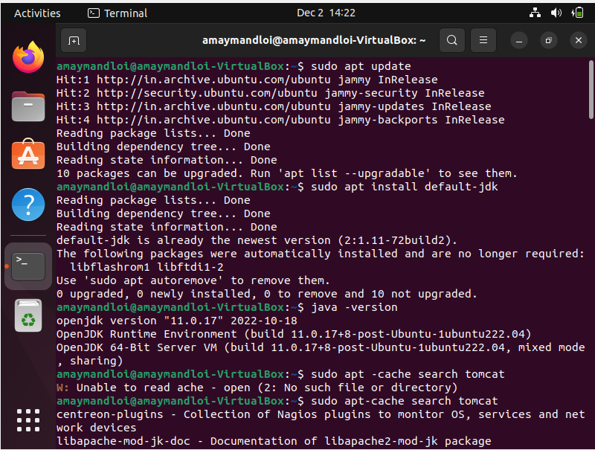

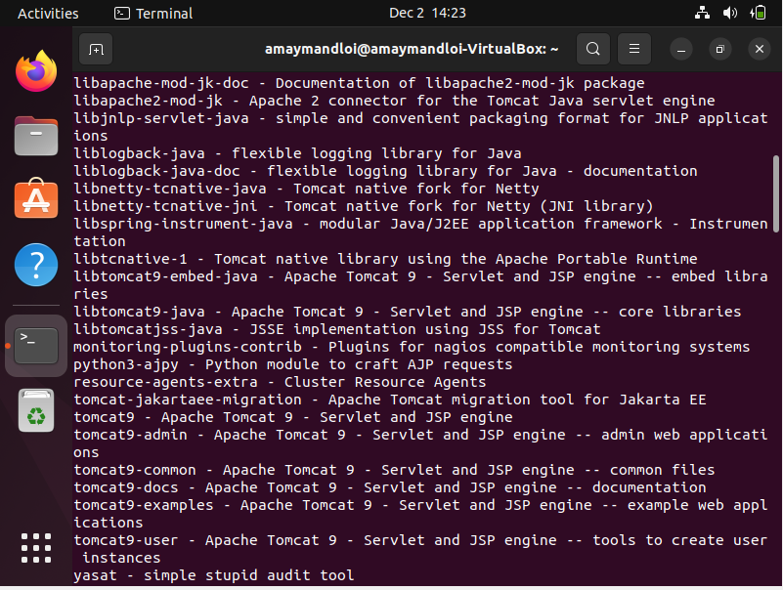

3. Install Apche Tomcat use Command :- sudo apt install tomcat9 tomcat9-admin.

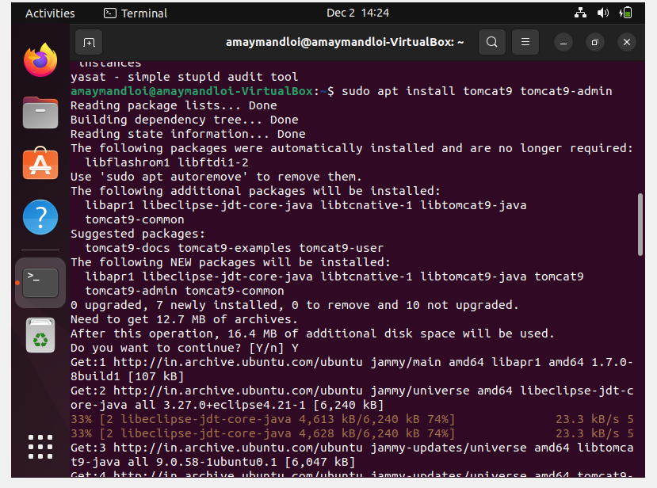

4. Allow to 8080 port Command- sudo ufw allow from any to any port 8080 proto tcp

5. check ip Address – ip addr

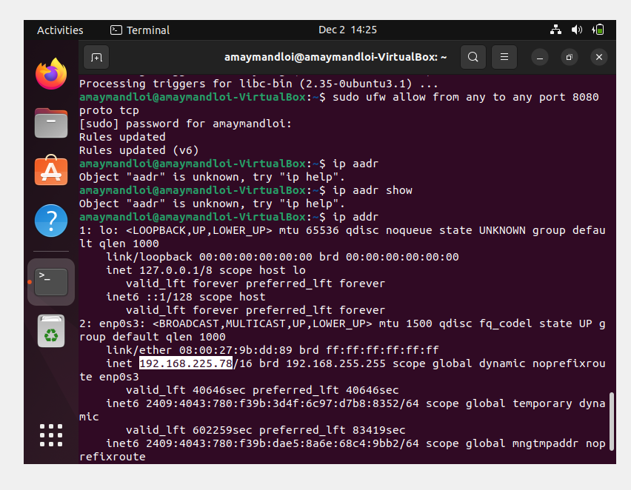

6. run in Browser IPaddress : port Number

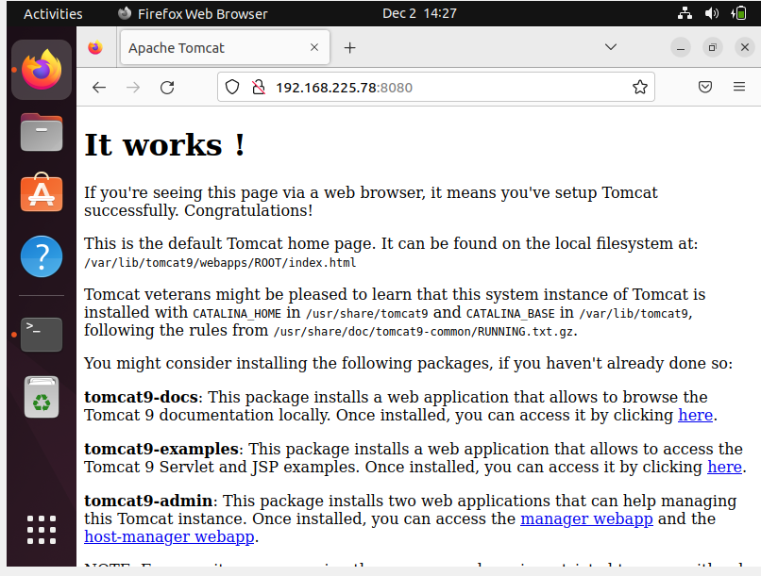

**Q.2**

**Create Rules IP table to Denny ICMP packet**

1. Firstly Install iptables use Command :- sudo apt-get install iptables
2. Iptable Details use Command:-sudo Iptables -S

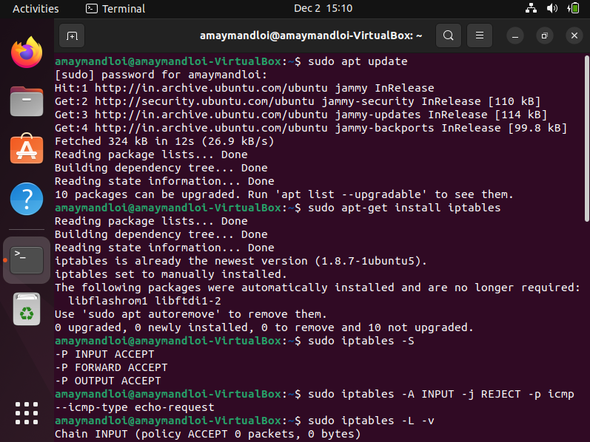

1. Ip address port unblock Use Command :- sudo Iptable -A Input -j REJECT -p icmp-icmp-type echo-request.

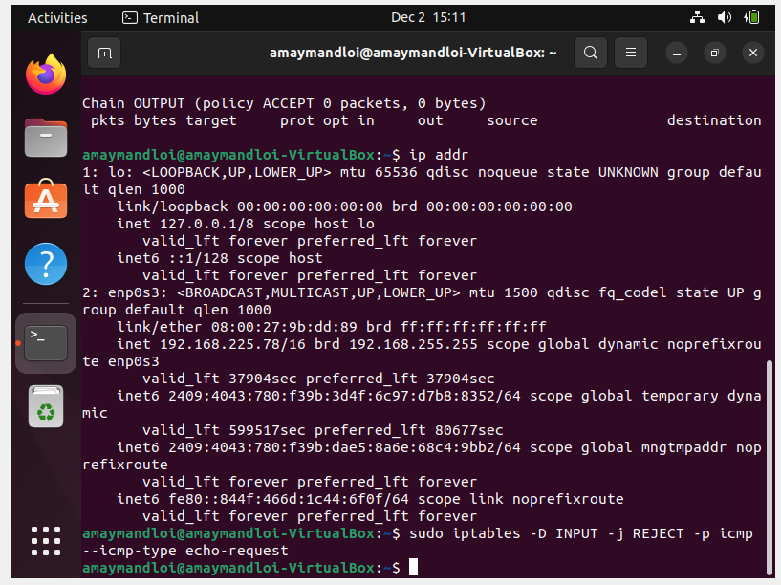

4.Ping Ip Address . Unblock

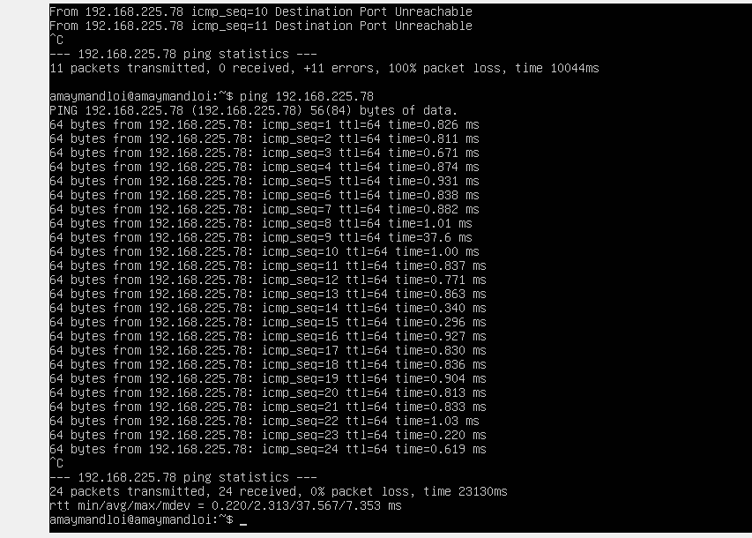

5.Ip address port block Use Command:- sudo iptables -A Input -j REJECT -p icmp – icmp-type echo-request

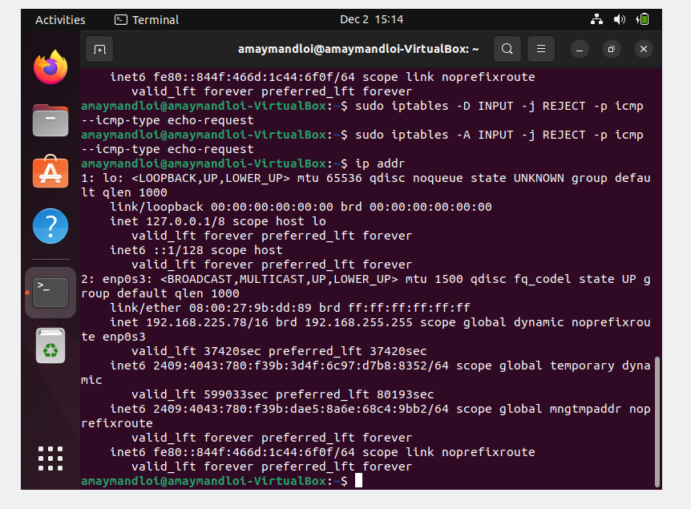

4.Ping Ip Address . block

